- Create VPC with 2 private and 2 public subnets.
• Open AWS Console → search VPC.
• Click Create VPC.
• Select VPC and more.
• Enter name tag: Demo(my-vpc) or your project name.
• Set IPv4 CIDR block: 10.0.0.0/16.
• Keep IPv6 as No IPv6 CIDR block.
• Keep tenancy as Default.
• Select 2 Availability Zones.
• Select 2 Public Subnets.
• Select 2 Private Subnets.
• Set NAT Gateway: None for this task.
• Keep VPC Endpoints unchecked/None.
• Enable DNS hostnames.
• Enable DNS resolution.
• Click Create VPC.
• Validate that VPC is Available.
• Validate that 4 subnets are created: 2 public and 2 private.
• Validate that route tables and Internet Gateway are created automatically

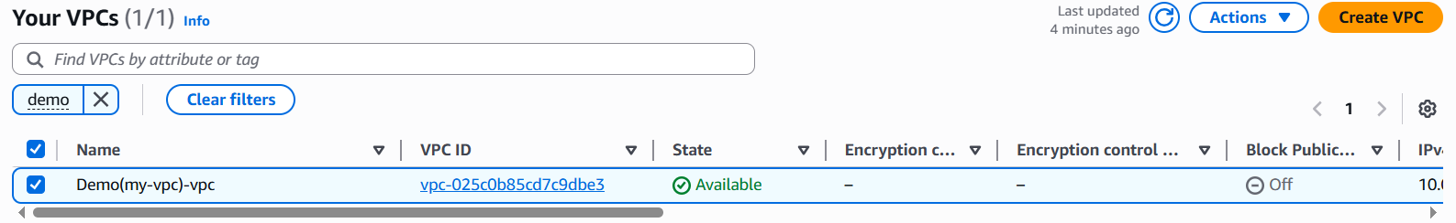
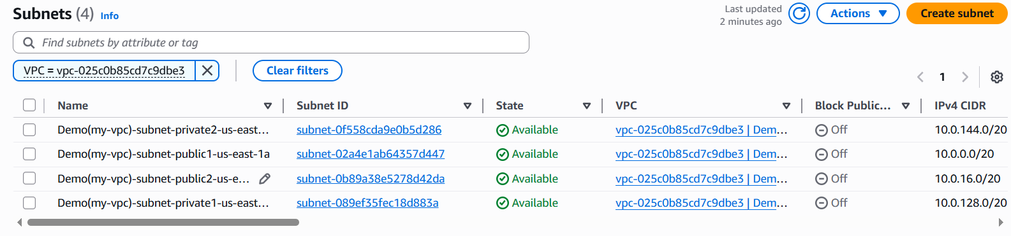

- Enable DNS Hostname in VPC.

Purpose : DNS hostnames and DNS resolution were enabled for the custom VPC Demo(my-vpc)-vpc. This allows EC2 instances launched in the VPC to receive public DNS names and resolve domain names correctly
AWS can assign DNS name like:
ec2-3-90-xx-xx.compute-1.amazonaws.com

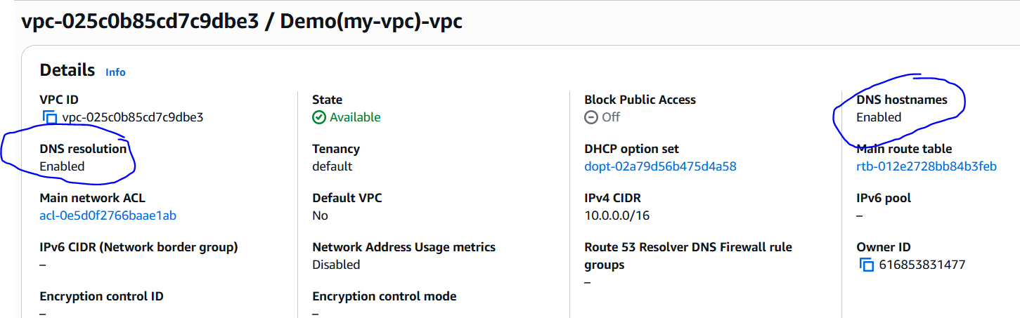

- Enable Auto Assign Public IP in 2 public subnets.
Purpose: The purpose is to make sure EC2 instances launched inside your public subnets automatically get a public IPv4 address.
Without public IP, your EC2 may be in a public subnet, but you still cannot access it from the internet using SSH or browser

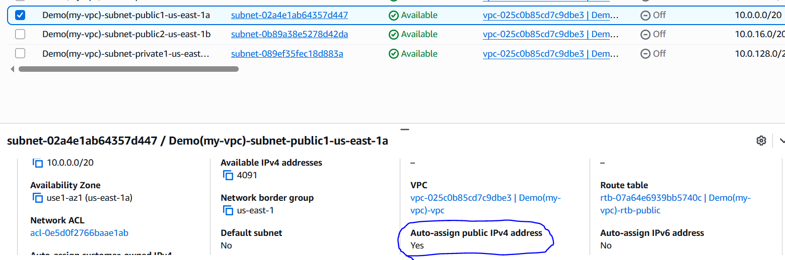
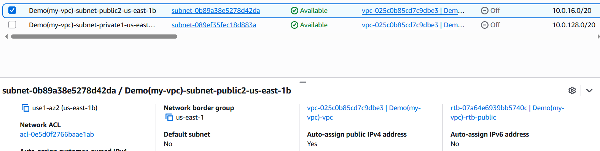

- Add 2 private subnets in private route table.
Purpose: The purpose is to make sure each private subnet is connected to its correct private route table.
Private subnets should not directly use the public route table because public route table has internet access through the Internet Gateway. Private route tables keep backend resources more secure. each private subnet should be associated with its own private route table, usually one per Availability Zone
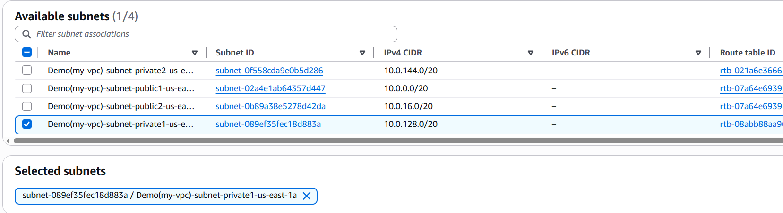
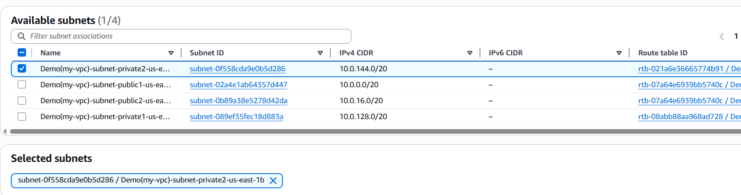

- Add 2 public subnets in public route table.
Purpose : The purpose is to connect both public subnets to the public route table.
Public route table is important because it has the internet route through the Internet Gateway. So any EC2 instance launched in the public subnet can access the internet and can be accessed from outside, if security group allows it. The document says both public subnets should be associated with the public route table
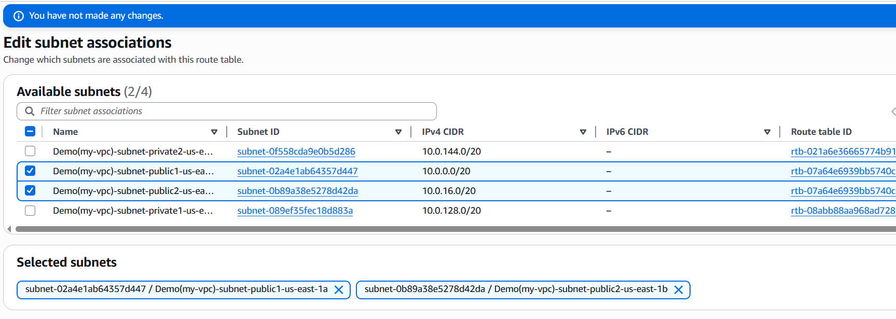
For validation you can see explicit subnet Association
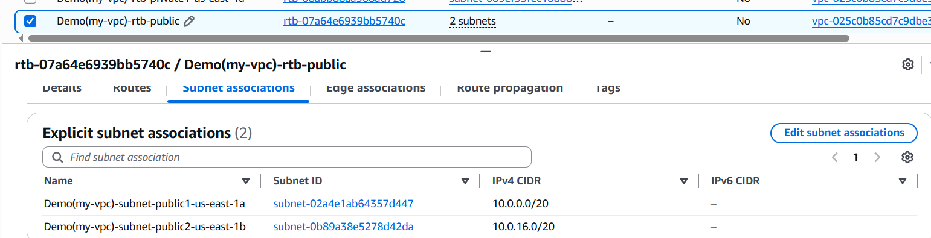

- Public route table will have the routes to internet and local.
Purpose: The purpose is to check that your public route table has the correct routes
So, public EC2 instances can communicate inside the VPC and also reach the internet through the Internet Gateway

local = communication between resources inside the same VPC
(If public EC2 wants to talk to private EC2:
This traffic uses the local route, because both IPs are inside the same VPC range)

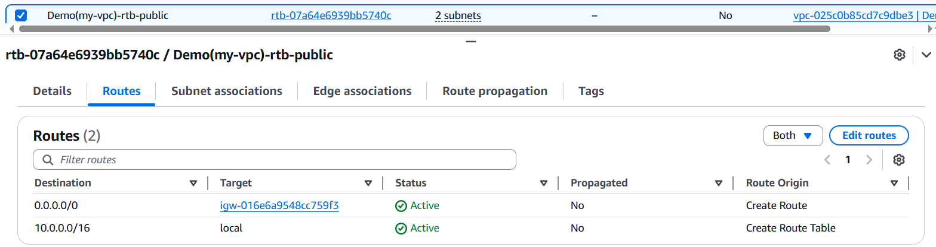

Every route is connected properly ………here

If 0.0.0.0/0 route is missing
Do this:
- Select Demo(my-vpc)-rtb-public
- Open Routes tab
- Click Edit routes
- Click Add route
- Enter:
Field | Value
Destination | 0.0.0.0/0
Target | Internet Gateway
Select IGW | Choose your attached Internet Gateway
- Click Save changes

- Create EC2 in public subnet with t2.micro and install PHP.

Purpose: You are launching one EC2 server in your public subnet and installing PHP on it. This proves your public subnet, public route table, Internet Gateway, security group, and public IP setup are working. says this EC2 should act like a basic PHP web server.
SSH is for connecting to the server. HTTP is for opening the PHP web page in browser.
- Go to EC2 service.
- Click Instances.
- Click Launch instance.
- Enter instance name: php-server.
- Select AMI: Amazon Linux 2023.
- Select instance type: t2.micro or t3.micro.
- Select existing key pair or create new key pair.
- In Network settings, click Edit.
- Select your VPC: Demo(my-vpc)-vpc.
- Select public subnet: Demo(my-vpc)-subnet-public1-us-east-1a.
- Set Auto-assign public IP to Enable.
- Create/select security group.
- Add inbound rule: SSH, port 22, source My IP.
- Add inbound rule: HTTP, port 80, source Anywhere IPv4 / 0.0.0.0/0.
- Keep storage as default.
- Click Launch instance.
- Wait until instance state becomes Running.
- Select instance and click Connect.
- Choose EC2 Instance Connect.
- Username should be ec2-user.
- Click Connect.
- Run update command:
sudo yum update -y
- Install Apache:
sudo yum install httpd -y
- Start Apache:
sudo systemctl start httpd
- Enable Apache on boot:
sudo systemctl enable httpd
- Check Apache status:
sudo systemctl status httpd
- Install PHP:
sudo yum install php php-cli php-mysqlnd -y
- Verify PHP:
php -v
- Create PHP test page:
echo "<?php phpinfo(); ?>" | sudo tee /var/www/html/index.php
- Restart Apache:
sudo systemctl restart httpd
- Copy EC2 Public IPv4 address.
- Open browser and enter:
http://your-public-ip

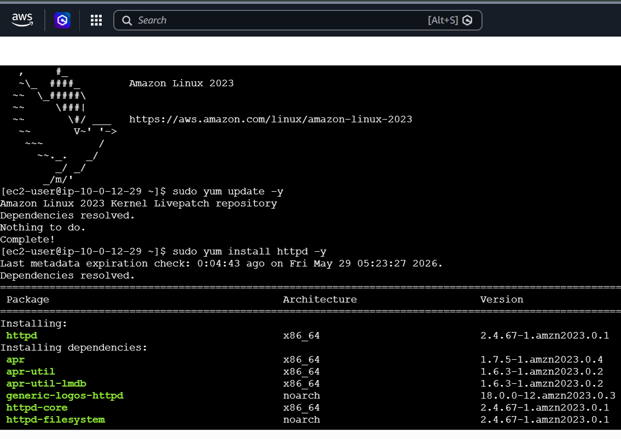
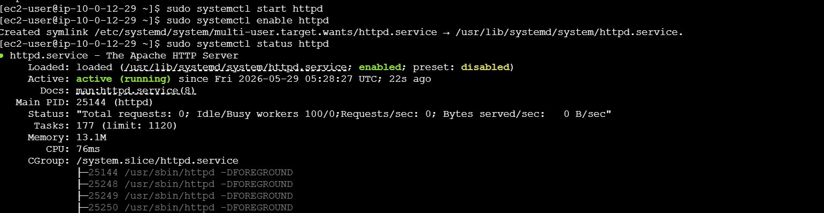
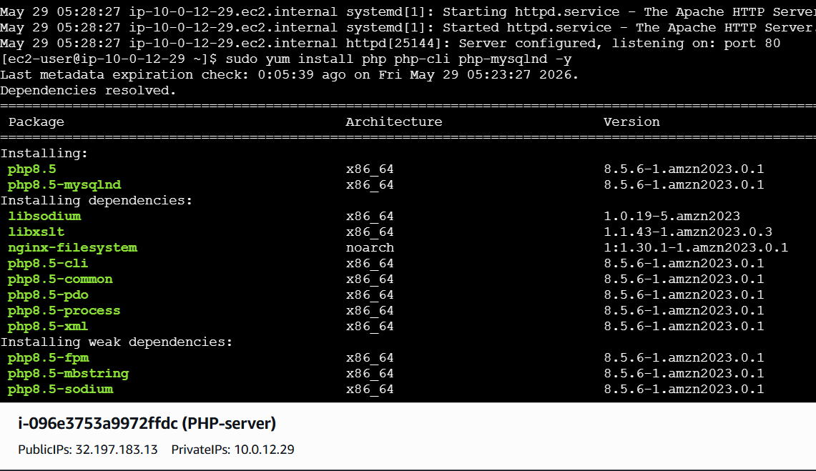

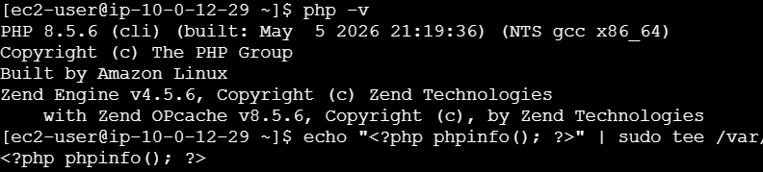

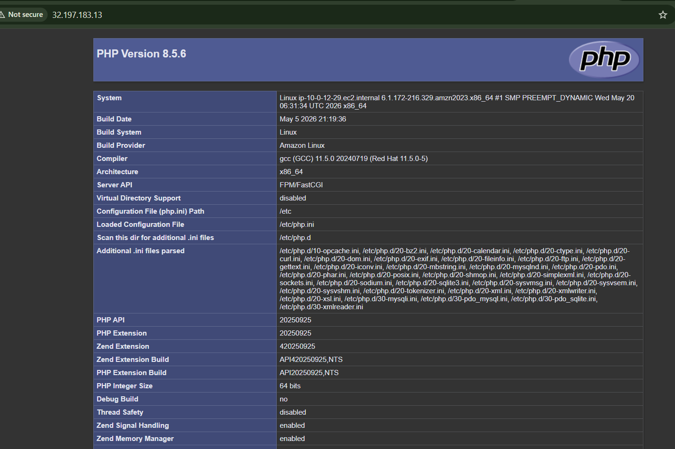

- Configure NAT gateway in public subnet and connect to private instance.
Purpose: The purpose is to allow a private EC2 instance to access the internet without giving it a public IP.
Private EC2 cannot directly access internet because it is inside a private subnet. But it still needs internet for:
- Installing packages
- Running updates
- Downloading software
- Accessing repositories
So we create a NAT Gateway in the public subnet. Then we update the private route table to send internet traffic through NAT Gateway
Flow : Private EC2 → NAT Gateway → Internet
So private EC2 gets safe outbound internet, but it is not directly exposed to the public internet
NAT Gateway needs an Elastic IP because it communicates with the internet
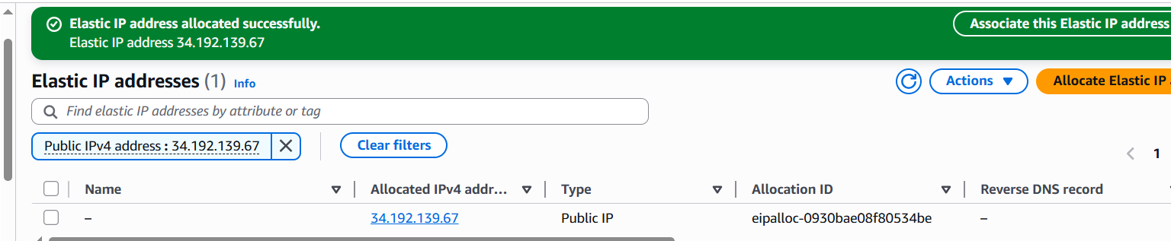
A NAT Gateway needs a public Elastic IP because it sits in the public subnet and sends private subnet traffic to the internet.
Flow will be:
Private EC2 → Private Route Table → NAT Gateway → Elastic IP → Internet

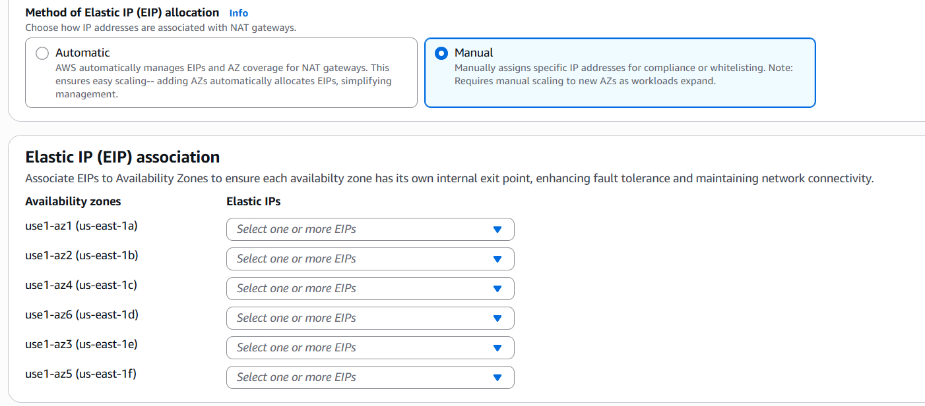
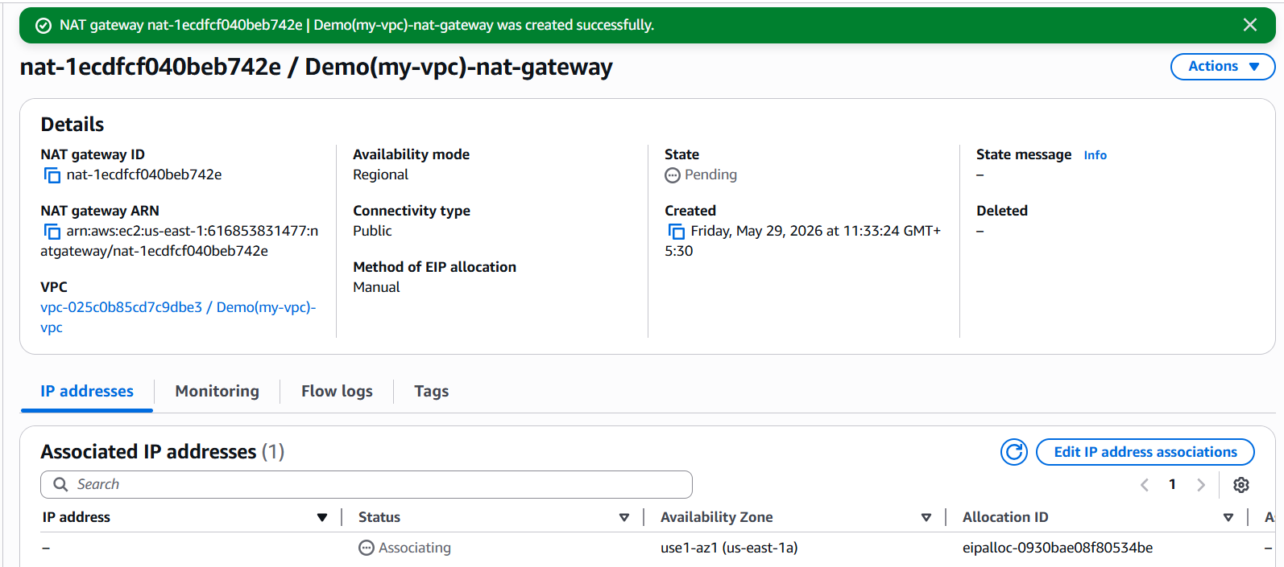

Add NAT Gateway route in private route tables
Once NAT Gateway becomes Available
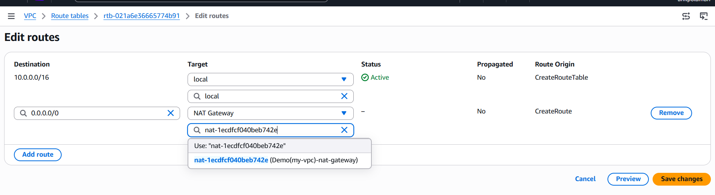
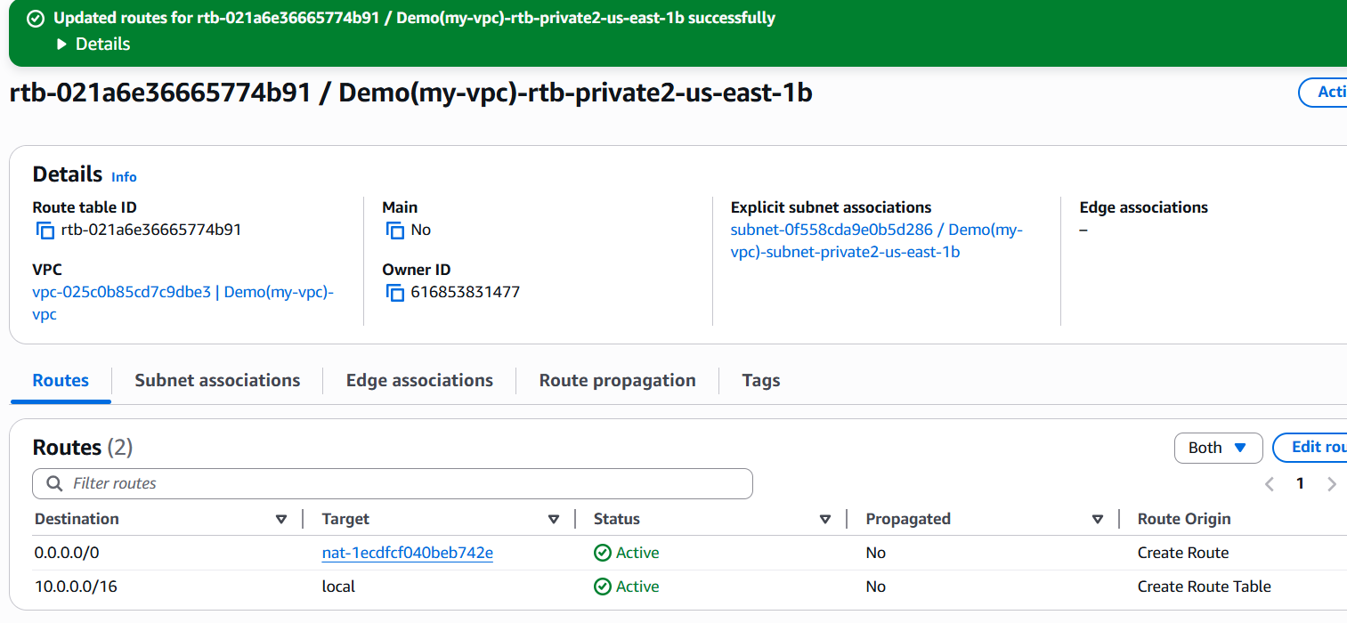
Now private subnet 1 can access internet through NAT Gateway.
Now private subnet 2 can access internet through NAT Gateway.
How to connect to a private instance and test internet from it
- Go to AWS Console.
- Search VPC and open it.
- On the left side, click Elastic IPs.
- Click Allocate Elastic IP address.
- Keep default settings.
- Click Allocate.
- On the left side, click NAT gateways.
- Click Create NAT gateway.
- Enter name: Demo(my-vpc)-nat-gateway.
- Select your VPC: Demo(my-vpc)-vpc.
- Select a public subnet, for example Demo(my-vpc)-subnet-public1-us-east-1a.
- Select Connectivity type: Public.
- Select Elastic IP allocation: Manual.
- Choose the Elastic IP you allocated.
- Click Create NAT gateway.
- Wait until NAT Gateway state becomes Available.
- Go to Route tables.
- Select private route table 1: Demo(my-vpc)-rtb-private1-us-east-1a.
- Open Routes tab.
- Click Edit routes.
- Click Add route.
- Enter destination: 0.0.0.0/0.
- Select target: NAT Gateway.
- Select your NAT Gateway: Demo(my-vpc)-nat-gateway.
- Click Save changes.
- Go back to Route tables.
- Select private route table 2: Demo(my-vpc)-rtb-private2-us-east-1b.
- Open Routes tab.
- Click Edit routes.
- Click Add route.
- Enter destination: 0.0.0.0/0.
- Select target: NAT Gateway.
- Select your NAT Gateway.
- Click Save changes.
- Validate both private route tables have 10.0.0.0/16 → local.
- Validate both private route tables have 0.0.0.0/0 → NAT Gateway.
- Go to EC2.
- Click Launch instance.
- Enter name: private-server.
- Select AMI: Amazon Linux 2023.
- Select instance type: t2.micro or t3.micro.
- Select the same key pair used for your public EC2.
- In Network settings, click Edit.
- Select VPC: Demo(my-vpc)-vpc.
- Select private subnet: Demo(my-vpc)-subnet-private1-us-east-1a.
- Set Auto-assign public IP to Disable.
- Create or select a security group for private EC2.
- Add inbound rule: SSH, port 22, source 10.0.0.0/16.
- Keep storage default.
- Click Launch instance.
- Wait until private EC2 state becomes Running.
- Select private EC2 and copy its Private IPv4 address.
- Confirm private EC2 has no Public IPv4 address.
- Go to your public EC2 from Task 7.
- Select the public EC2.
- Click Connect.
- Choose EC2 Instance Connect.
- Username should be ec2-user.
- Click Connect.
- Inside public EC2 terminal, create key file using:
vi Techie.pem
- Paste your .pem key content.
- Save using Ctrl + O, press Enter, then Ctrl + X.
- Set key permission:
chmod 400 Techie.pem
- Connect from public EC2 to private EC2:
ssh -i Techie.pem ec2-user@<private-ec2-private-ip>
- Type yes if it asks for confirmation.
- Now you are inside the private EC2.
- Test internet through NAT Gateway:
curl https://amazon.com
- Or test with:
ping google.com
- If the command works, NAT Gateway is working

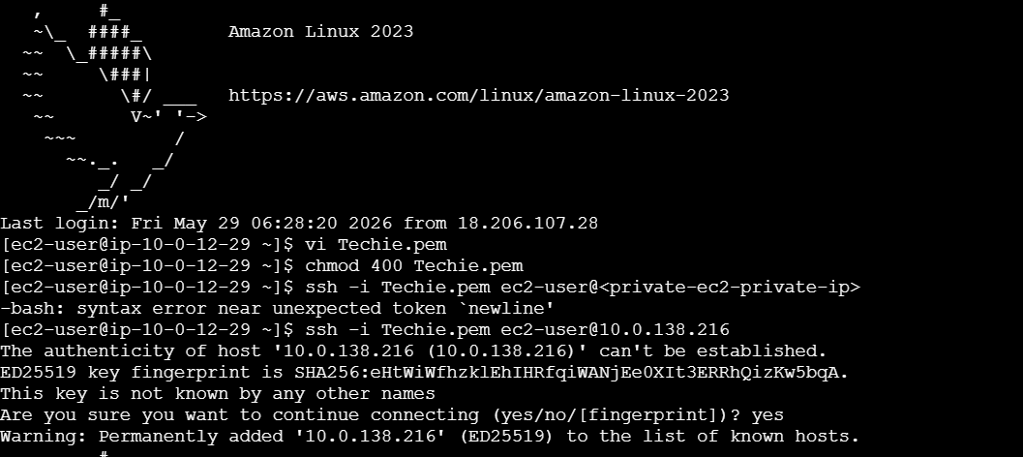

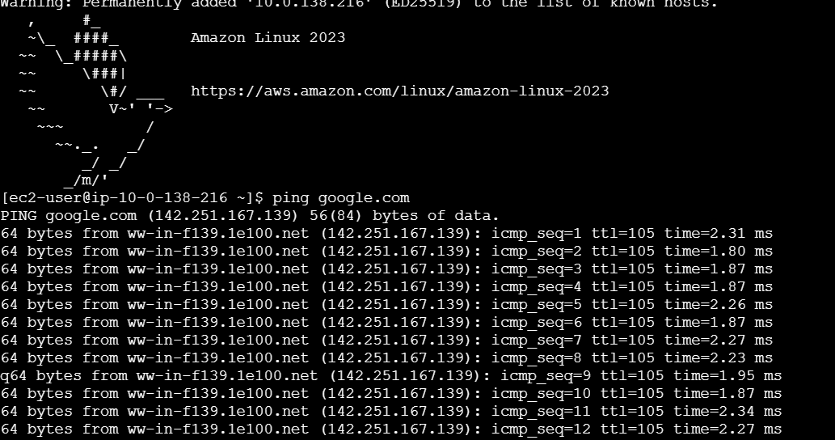

- Install Apache Tomcat in private EC2 and deploy a sample app.

Purpose : In this task, you install Java 21 and Apache Tomcat on the private EC2 instance. This private EC2 stays secure inside the private subnet, but it can still download software using the NAT Gateway . expected outcome is Java 21 installed, Tomcat installed, Tomcat running on port 8080, sample app deployed, and private EC2 remains secure

- Use your existing public EC2 as the jump server/bastion host.
- Use your existing private EC2 as the Tomcat server.
- Confirm private EC2 is in the private subnet.
- Confirm private EC2 has no public IPv4 address.
- Confirm private EC2 has a private IPv4 address, example: 10.0.138.216.
- Confirm NAT Gateway is Available.
- Confirm private route table has 0.0.0.0/0 → NAT Gateway.
- Go to private EC2 security group.
- Add inbound rule: SSH, port 22, source 10.0.0.0/16.
- Add inbound rule: Custom TCP, port 8080, source 10.0.0.0/16.
- Go to EC2 → Instances.
- Select your public EC2.
- Click Connect.
- Select EC2 Instance Connect.
- Username should be ec2-user.
- Click Connect.
- Inside public EC2, create/copy your key file if it is not already there:
vi Techie.pem
- Paste your .pem private key content.
- Save using Ctrl + O, press Enter, then Ctrl + X.
- Give permission to key file:
chmod 400 Techie.pem
- Connect from public EC2 to private EC2:
ssh -i Techie.pem ec2-user@10.0.138.216
- Type yes if it asks for confirmation.
- Now you are inside the private EC2.
- Test NAT internet access from private EC2:
curl https://amazon.com
- Update private EC2 packages:
sudo dnf update -y
- Install Java 21:
sudo dnf install java-21-amazon-corretto -y
- Verify Java installation:
java -version
- Go to /tmp:
cd /tmp
- Install wget:
sudo dnf install wget -y
- Download Apache Tomcat:
wget https://downloads.apache.org/tomcat/tomcat-10/v10.1.55/bin/apache-tomcat-10.1.55.tar.gz
- Extract Tomcat:
tar -xvzf apache-tomcat-10.1.55.tar.gz
- Move Tomcat to /opt/tomcat:
sudo mv apache-tomcat-10.1.55 /opt/tomcat
- Give execute permission to Tomcat scripts:
sudo chmod +x /opt/tomcat/bin/*.sh
- Start Tomcat:
sudo /opt/tomcat/bin/startup.sh
- Verify Tomcat process:
ps -ef | grep tomcat
- Check Tomcat is listening on port 8080:
sudo ss -tulnp | grep 8080
- Go to Tomcat webapps folder:
cd /opt/tomcat/webapps
- Create sample app folder:
sudo mkdir sampleapp
- Create sample JSP page:
echo "<h1>Apache Tomcat Application Deployed Successfully</h1>" | sudo tee /opt/tomcat/webapps/sampleapp/index.jsp
- Exit from private EC2:
exit
- Now you are back in public EC2.
- Test Tomcat from public EC2 using private EC2 IP:
curl http://10.0.138.216:8080
- Test sample app:
curl http://10.0.138.216:8080/sampleapp/
- Expected output:
<h1>Apache Tomcat Application Deployed Successfully</h1>
- Do not open 10.0.138.216:8080 from your laptop browser because 10.0.138.216 is a private IP.
- Private IP works only inside the VPC.
- Correct testing method is from public EC2 terminal using curl.
- Take screenshot of java -version.
- Take screenshot of Tomcat started.
- Take screenshot of ps -ef | grep tomcat
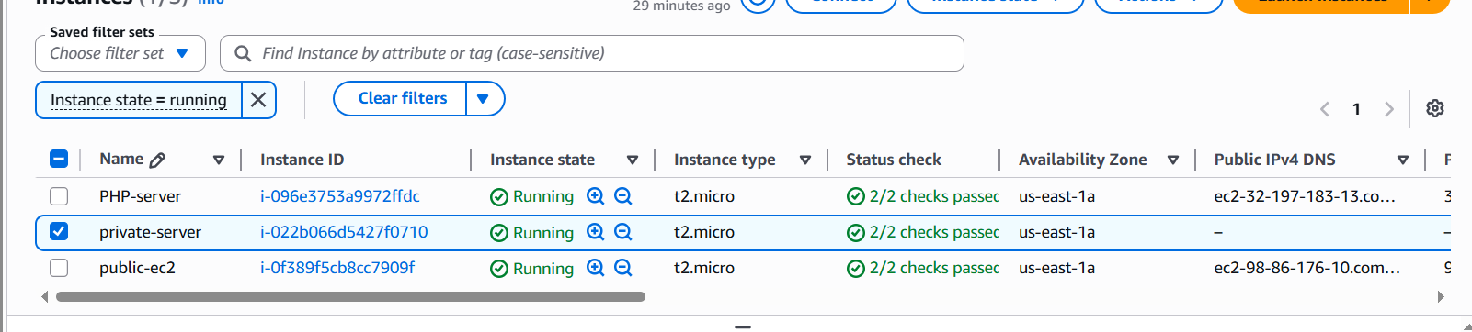

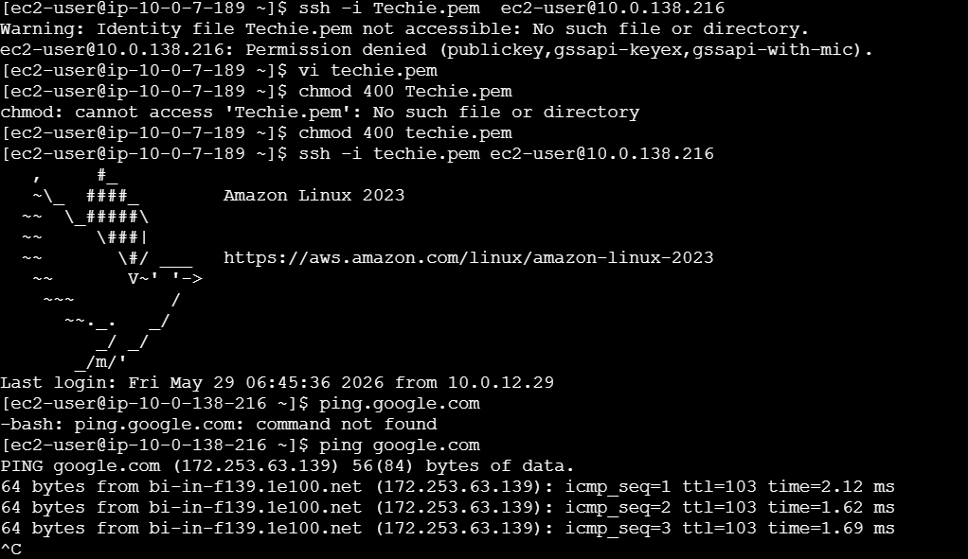
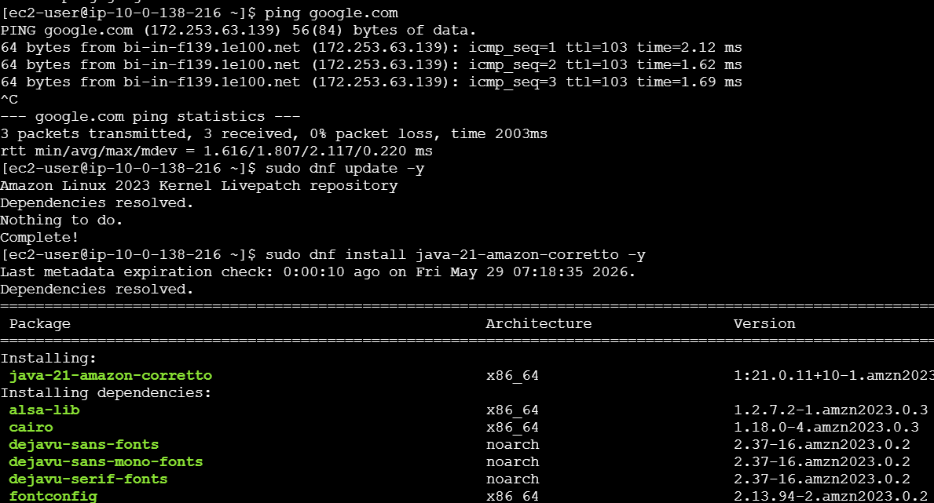
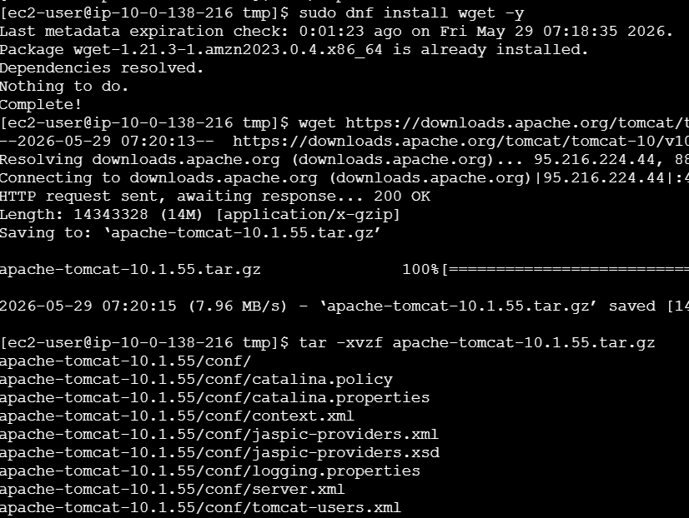
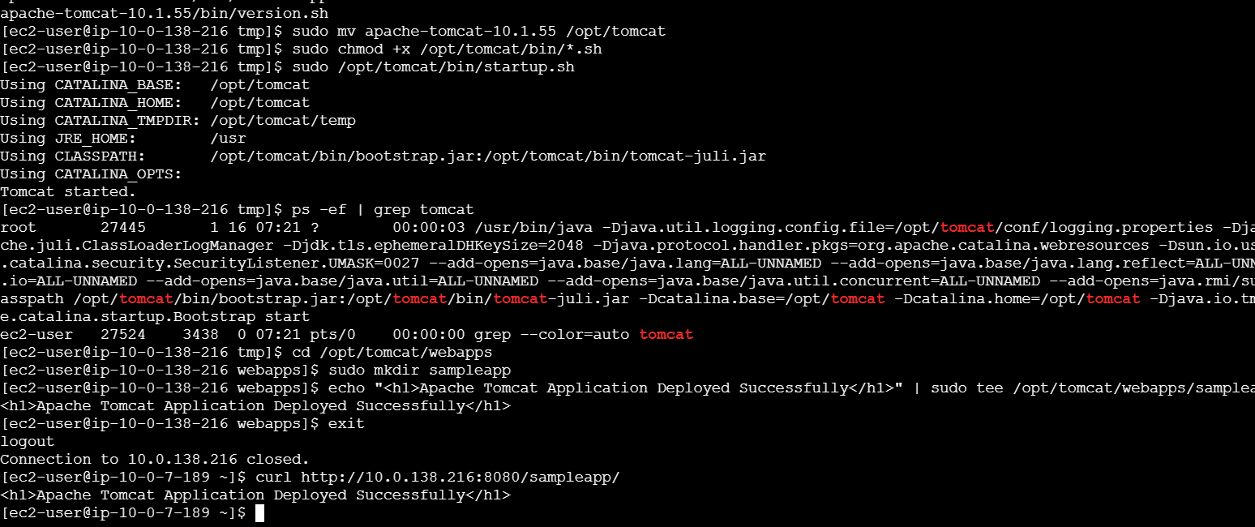

- Configure VPC flow logs and store the logs in S3 and CloudWatch.

Purpose: • Which traffic is allowed
• Which traffic is rejected
• Source IP and destination IP
• Port numbers
• Troubleshooting SSH, HTTP, Tomcat, NAT Gateway issues
• Security monitoring

- Go to AWS Console.
- Search CloudWatch.
- Open CloudWatch.
- On the left side, under Logs, click Log Management.
- Click Create log group.
- Enter log group name:
vpc-flow-logs
- Click Create.
Purpose: This creates a place in CloudWatch where VPC traffic logs will be stored.
Create IAM Role for CloudWatch Flow Logs
- Go to IAM.
- Click Roles.
- Click Create role.
- Select Custom trust policy.
- Paste this policy:
{
"Version": "2012-10-17",
"Statement": [
{
"Effect": "Allow",
"Principal": {
"Service": "vpc-flow-logs.amazonaws.com"
},
"Action": "sts:AssumeRole"
}
]
}
- Click Next.
- Search permission policy:
CloudWatchLogsFullAccess
- Select it.
- Click Next.
- Role name:
VPCFlowLogsRole
- Click Create role.
Purpose: This IAM role gives permission for VPC Flow Logs to send traffic logs into CloudWatchCreate CloudWatch Flow Log
- Go to VPC.
- Click Your VPCs.
- Select your VPC:
Demo(my-vpc)-vpc
- Open the Flow logs tab.
- Click Create flow log.
- Set Filter to:
All
- Set Maximum aggregation interval to:
1 minute
- Set Destination to:
Send to CloudWatch Logs
- Select log group:
vpc-flow-logs
- Select service role:
VPCFlowLogsRole
- Keep Log record format as:
AWS default format
- Click Create flow log.
Purpose: This sends your VPC traffic logs to CloudWatch so you can view and monitor them easily Use existing S3 bucket
You already created this S3 bucket:
demo-s3-bucket-2528
Its ARN is automatically:
arn:aws:s3:::demo-s3-bucket-2528
You do not need to create the ARN manually. AWS automatically gives every bucket an ARN.
Purpose: S3 is used for long-term storage of VPC traffic logs.
Create S3 Flow Log
- Go back to VPC.
- Click Your VPCs.
- Select:
Demo(my-vpc)-vpc
- Open Flow logs tab.
- Click Create flow log again.
- Set Filter to:
All
- Set Maximum aggregation interval to:
1 minute
- Set Destination to:
Send to an S3 bucket
- In S3 bucket ARN, enter:
arn:aws:s3:::demo-s3-bucket-2528
- Keep Log record format as:
AWS default format
- Click Create flow log.
Purpose: This sends another copy of your VPC traffic logs to S3 for storage.
Validate Task 10
- Go to VPC → Your VPCs.
- Select Demo(my-vpc)-vpc.
- Open Flow logs tab.
- You should see 2 flow logs.
Expected:
Flow log | Destination | Status
Flow log 1 | CloudWatch Logs | Active
Flow log 2 | S3 bucket | Active
- To generate traffic, connect to EC2 and run:
curl https://amazon.com
- Wait a few minutes.
- Check logs in CloudWatch → Logs → Log Management → vpc-flow-logs.
- Check logs in S3 → demo-s3-bucket-2528 → AWSLogs folder.

